AZ-104 Microsoft Azure Administrator Practice Exams

# Azure File

1. Deploy the Azure File Sync agent to server

2. Register server with Storage Sync Service

3. Create a sync group and a cloud endpoint

4. Create a server endpoint

Cannot have more than 1 server endpoint (filepath) from the same server in the same sync group.

Can only have 1 cloud endpoint (azure fileshare) per sync group

# Azure Storage

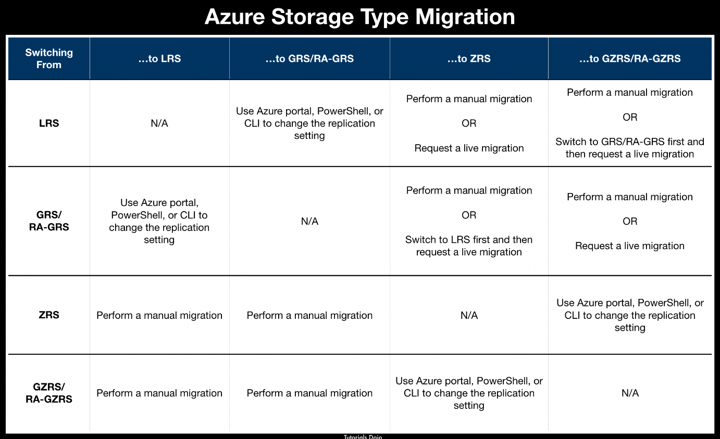

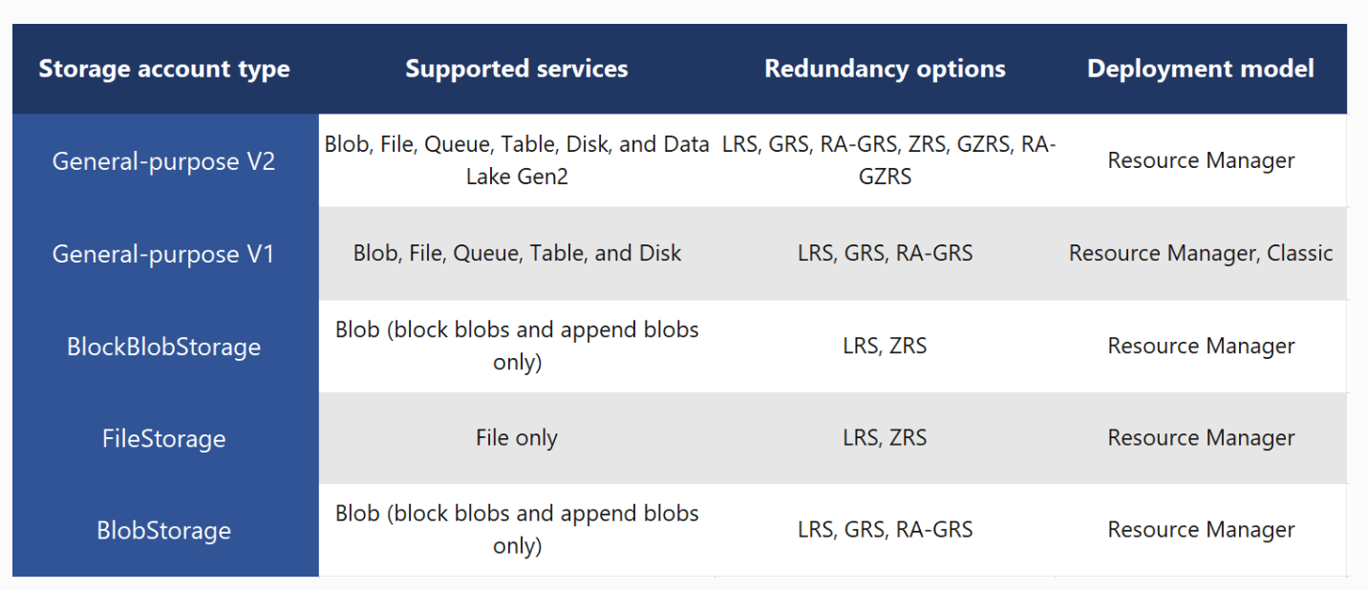

# Azure Import/Export service

Only BLOB is supported for export service

# AzureAD

Only TXT or MX is supported

# Azure site to site vpn

1. Deploy a gateway subnet

2. Deploy a VPN gateway

3. Deploy a local network gateway

4. Deploy a VPN connection

# Azure LB

Basic: only VMs in same availability sets or scale set

Standard: any VMs in single vnet

# Azure Recovery services vault

You can only backup data sources or VMs that are in the same region

# Azure Disks

Linux temp disk is /dev/sdb, windows is D:

If redeploy, files in these folders are gone.

# Azure VM Scale set

Uniform – for stateless workload

Flexible - offers high availability with identical or multiple VM types (up to 1000 VMs) by spreading VMs across fault domains in a region or within an Availability Zone.

# Azure VM cpu quota

The vCPUs must not exceed the vCPU quota for the VM size family or the total regional vCPU

# Azure availability set

To ensure that the application is available during planned maintenance, you must assign two update domains in the Availability Set. An update domain will make sure that the VMs in the Availability Set are not updated at the same time.

Fault domain is mainly used for unplanned maintenance.

The update domain count must be 1 when fault domain count is 1.